

Requirements Analysis &
System Modeling
Online Course Registration System

Basmala Salah Mohamed
Rana Abdelhamid Dief

State Machine Diagram:

- Registration State Machine:

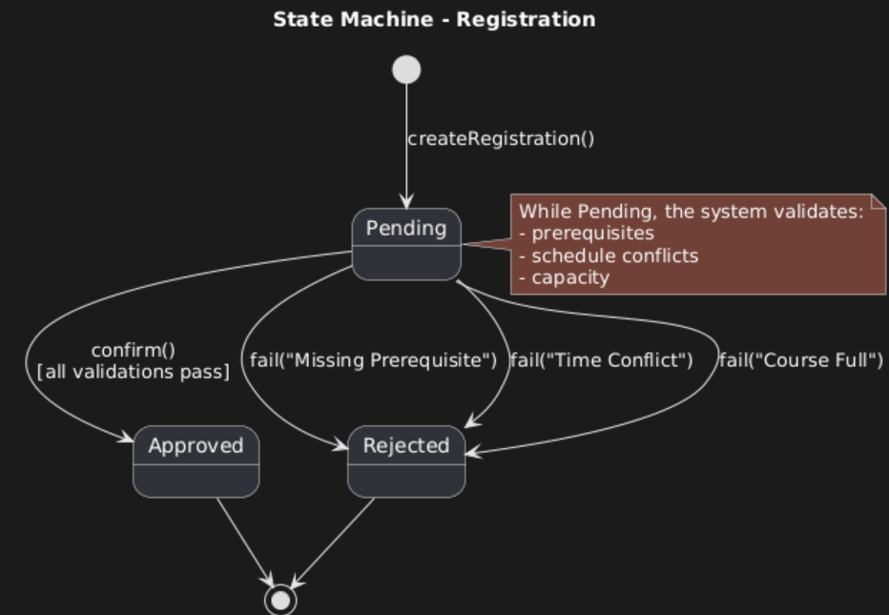

- Course Registration Attempt (Process State Machine):
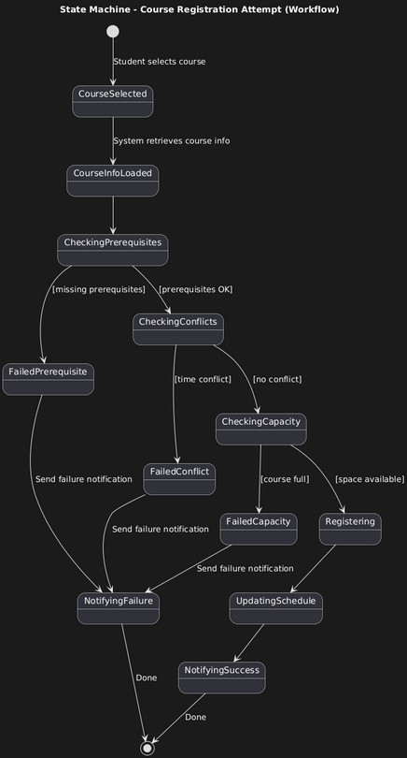

- User Session State Machine:

